**INTEGER RESTORING DIVISION:**

**EXP 33**

#include<stdlib.h>  
  
  
#include<stdio.h>  
  
  
int acum[100]={0}            ;  
  
  
void add(int acum[],int b[],int  
n);  
  
  
int q[100],b[100];  
  
  
int main()  
  
  
{  
  
  
int x,y;  
  
  
printf("Enter the Number  
:");  
  
  
scanf("%d%d",&x,&y);  
  
  
int i=0;  
  
  
while(x>0||y>0)  
  
  
{  
  
  
if(x>0)  
  
  
{  
  
  
q[i]=x%2;  
  
  
x=x/2;  
  
  
}  
  
  
else  
  
  
{  
  
  
q[i]=0;  
  
  
}  
  
  
if(y>0)  
  
  
{  
  
  
b[i]=y%2;  
  
  
y=y/2;  
  
  
}  
  
  
else  
  
  
{  
  
  
b[i]=0;  
  
  
}  
  
  
i++;  
  
  
}  
  
  
                 
  
  
int n=i;  
  
  
int bc[50];             
  
  
printf("\n");  
  
  
for(i=0;i<n;i++)  
  
  
{  
  
  
if(b[i]==0)  
  
  
{  
  
  
bc[i]=1;  
  
  
}  
  
  
else  
  
  
{  
  
  
bc[i]=0;  
  
  
}  
  
  
}  
  
  
bc[n]=1;  
  
  
for(i=0;i<=n;i++)  
  
  
{  
  
  
if(bc[i]==0)  
  
  
{  
  
  
bc[i]=1;  
  
  
i=n+2;  
  
  
}  
  
  
else  
  
  
{  
  
  
bc[i]=0;  
  
  
}  
  
  
}  
  
  
int l;  
  
  
 b[n]=0;  
  
  
int k=n;  
  
  
int n1=n+n-1;  
  
  
int j,mi=n-1;  
  
  
for(i=n;i!=0;i--)  
  
  
{  
  
  
for(j=n;j>0;j--)  
  
  
{  
  
  
acum[j]=acum[j-1];          
  
  
                 
  
  
}  
  
  
acum[0]=q[n-1];  
  
  
for(j=n-1;j>0;j--)  
  
  
{  
  
  
q[j]=q[j-1];  
  
  
}  
  
  
   
  
  
add(acum,bc,n+1);  
  
  
if(acum[n]==1)  
  
  
{  
  
  
q[0]=0;  
  
  
add(acum,b,n+1);  
  
  
}  
  
  
else  
  
  
{  
  
  
q[0]=1;  
  
  
}               
  
  
}  
  
  
printf("\nQuoient   : ");  
  
  
   
  
  
for(  l=n-1;l>=0;l--)  
  
  
{  
  
  
printf("%d",q[l]);  
  
  
   
  
  
}  
  
  
printf("\nRemainder :  
");  
  
  
for( l=n;l>=0;l--)  
  
  
{  
  
  
printf("%d",acum[l]);  
  
  
}  
  
  
return 0;                
  
  
}  
  
  
void add(int acum[],int bo[],int  
n)  
  
  
{  
  
  
int i=0,temp=0,sum=0;  
  
  
for(i=0;i<n;i++)  
  
  
{               
  
  
sum=0;  
  
  
sum=acum[i]+bo[i]+temp;  
  
  
if(sum==0)  
  
  
{  
  
  
acum[i]=0;  
  
  
temp=0;  
  
  
}               
  
  
else if (sum==2)  
  
  
{  
  
  
acum[i]=0;  
  
  
temp=1;                
  
  
}  
  
  
else if(sum==1)  
  
  
{  
  
  
acum[i]=1;  
temp=0;                
}  
else if(sum==3)  
{  
a cum [i]=1;  
temp=1;  
}  
  
}  
  
}

**INPUT:**

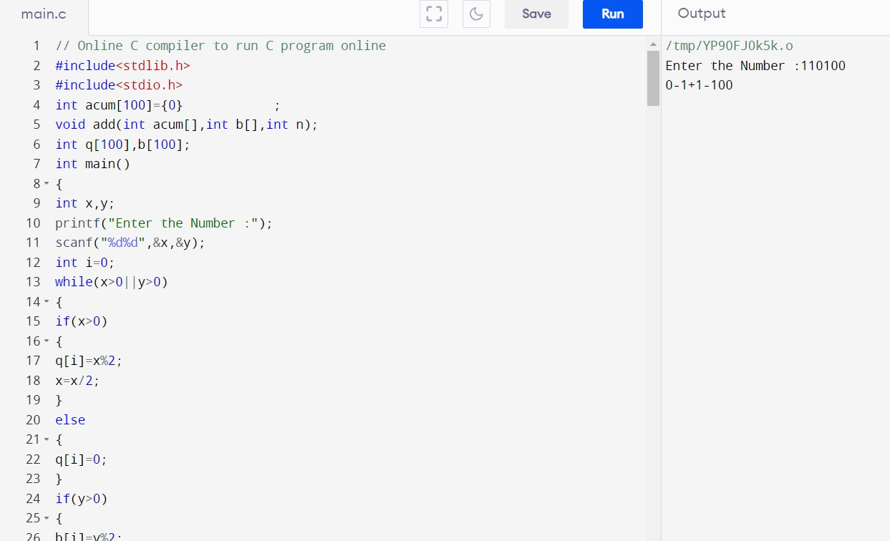

**OUTPUT:**

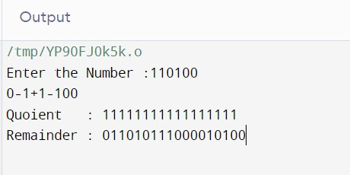

**RESULT:**Thus the program was executed successfully using Dev C++.